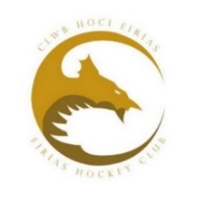 **Eirias Membership 2025-26 Season**

The committee have reviewed and endorsed the membership fee and associated rates for the upcoming season. During this process, we have been mindful of the planned increase for Hockey Wales affiliation which has been necessary following the significant reduction in central funding from Sports Wales.

The responsibility for payment of Hockey Wales affiliation remains with the player and we as a club have no influence over this. As a reminder the rates for 2025-26 Hockey Wales affiliation will be:

Adult Players (18 and Over) £59.00

Players Age 14 to 17 £35.00

Players Age 13 and Under £25.00

These rates will be reviewed in 3 years by Hockey Wales

**Eirias Membership**

The committee have agreed to:

* maintain the mileage rate at 30p per mile
* maintain match fees at the current rate of 10 for adults and 8 for juniors
* maintain the position of Goalkeepers who provide their own kit having their membership fee waived

We have made a modest increase to the minis membership fees however we have been able to maintain Adult and Junior U18 membership fees

Adult Early Bird 125 Full 150

Junior U18 Early Bird 100* Full 125*

Juniors Minis Early Bird 50 Full 70

*Including unemployed, apprentice and student in full time education

Adult and U18 Membership Fees are to be paid before the 1st September 2024 otherwise current members cannot play or train (early bird also finishes on this date)

Mini (Year 7 and Below) Membership Fees are to be paid before the 1st October 2024 otherwise current members cannot play or train (early bird also finishes on this date)

Family discounts remain unchanged @ 10% for 3 family members living at the same address

We would like to continue with our offer to pay in three instalments over June/July/August for Adults / Junior U18 and July/August/September for Junior Minis.

This years membership form will come through Spond, you will have the option of paying through Spond or the clubs bank account. Payment by Spond has a transaction fee of 2.5% plus 20p which the club will absorb, if you chose to pay by bank transfer this will save the club paying any transaction fee.

We hope you find the fees acceptable; the committee have committed to keep costs down and hope to see you all back for the new season

Kind regards

Membership Secretary