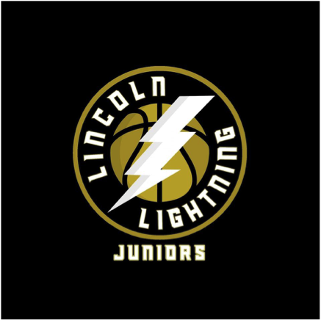

[lincolnlightningjuniors@gmail.com](mailto:lincolnlightningjuniors@gmail.com)

Updated - 6 February 2025

**LLJBC Photography and image Policy**

LLJBC is committed to providing a safe environment for children to participate. Essential to this commitment is to ensure that all necessary steps are taken to prevent inappropriate images being taken or innocent images being adapted for inappropriate use. Please note the term ‘images’ refers to photographs and videos captured by any device.

LLJBC requests on joining the Club that parents/guardians permit LLJBC staff and authorised representatives to take images at appropriate times to be used for the benefit of the club, to assist coaching activity, encourage team bonding or for publicity.

**If you do not wish to provide permission for images then please inform the Head Coach in writing (for our records) that you do not provide consent for imagery.**

Our policy, in line with Basketball England states:

* Parents/guardians and children have a right to decide if their images are to be taken, and how those images may be used;
* Parents/guardians and players can withdraw their consent for images to be taken or used at any time by informing the Head or Senior coach and follow up in writing (for our records); should this occur LLJBC will commit to removing any images they have control over, noting that some images in the public domain may be out of the control of the Club;
* Parents/guardian should request permission from coaching staff prior to taking images, the staff will be aware of any restriction in place - specific authorisation is required at the Notts CVL;
* Images should convey the best principles and aspects of basketball, such as fairness, fun, camaraderie and athleticism;
* Images will never be taken in changing rooms;

LLJBC Staff