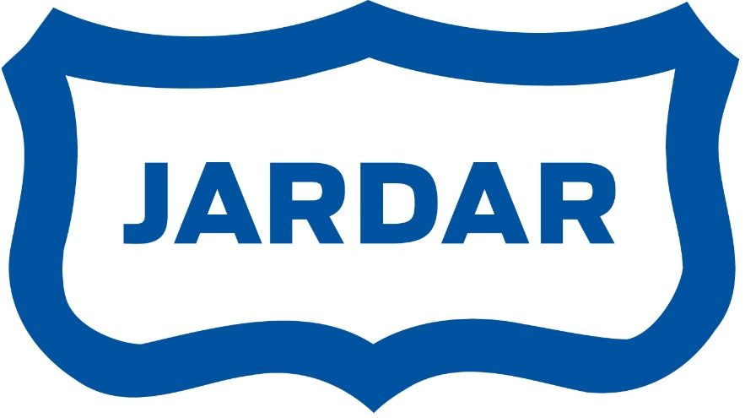

Diplom

tildeles

________________________________________

Takk for innsatsen

IL Jardar

